WIGAN SWIMMING CLUB SPONSORSHIP FORM
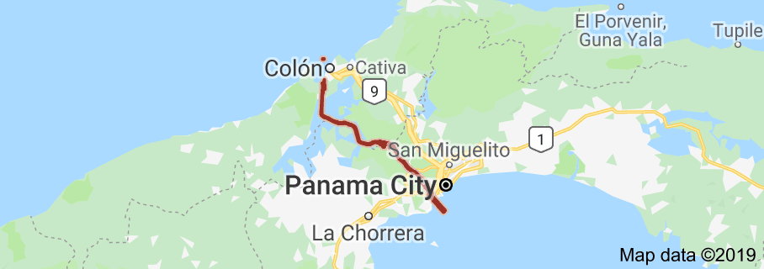 Panama Canal (50 miles) at Wigan Life Centre
Sunday 8th September 2019 1 – 4pm
Please enter amount per mile (max 50 miles) or simply enter total amount willing to sponsor swimmer

Swimmers name……….

Full Name | Home Address (optional) | Postcode | Per Mile | £ Sponsored | Date  Paid
Swimmers, thank you for taking part. Please return your completed form, together with cheque(s) made payable to Wigan Swimming Club or monies to a member of the club committee.

