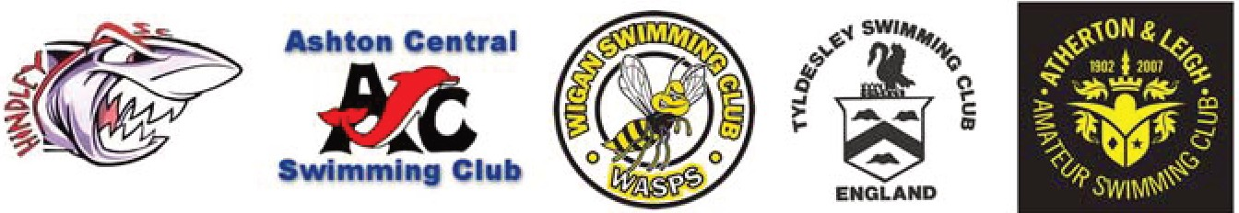

Wigan Development Meet 2024
Wigan Borough Community Swimming Clubs

Program of Events

Session

Warm Up: 12:00 Noon Start: 12:30pm

No. Event
- Girls 8 Years 25m Freestyle
- Boys 8 Years 25m Freestyle
- Girls 9-11 Years 50m Backstroke
- Boys 9-11Years 50m Backstroke
- Girls 8 Years 25m Butterfly
- Boys 8 Years 25m Butterfly
- Girls 9-11 Years 50m Breaststroke
- Boys 9-11Years 50m Breaststroke
- Girls 8 Years 25m Backstroke
- Boys 8 Years 25m Backstroke
- Girls 9-11 Years 50m Freestyle
- Boys 9-11Years 50m Freestyle
- Girls 8 Years 25m Breaststroke
- Boys 8 Years 25m Breaststroke
- Girls 9-11 Years 50m Butterfly
- Boys 9-11Years 50m Butterfly

l/owe ACES
HRJn GF

